Вариант 14 (0, 1, 2, 5, 7)
Задание 1
Аргументы (входы) |  |  |  |  | Функции
x₇ | x₅ | x₂ | x₁ | x₀ | y₂ | y₁ | y₀
(x₅) | (x₄) | (x₃) | (x₂) | (x₁) | (y₃) | (y₂) | (y₁)
0 | 0 | 0 | 0 | 1 | 0 | 0 | 0
0 | 0 | 0 | 1 | 0 | 0 | 1 | 0
0 | 0 | 1 | 0 | 0 | 1 | 0 | 0
0 | 1 | 0 | 0 | 0 | 1 | 0 | 1
1 | 0 | 0 | 0 | 0 | 1 | 1 | 1

y₀ = x₅ v x₇
y₁ = x₁ v x₇
y₂ = x₂ v x₅ v x₇

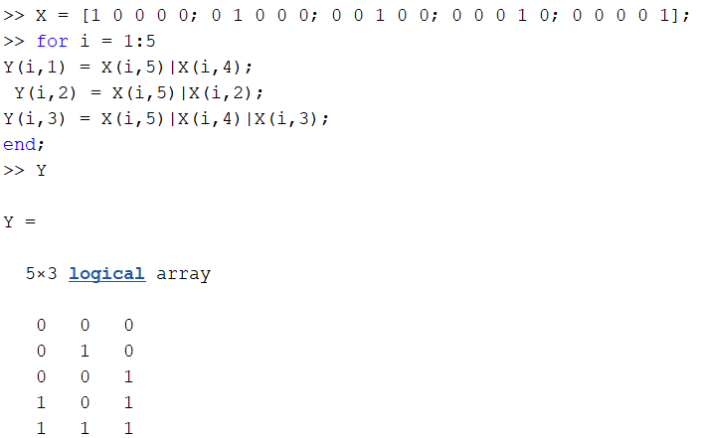

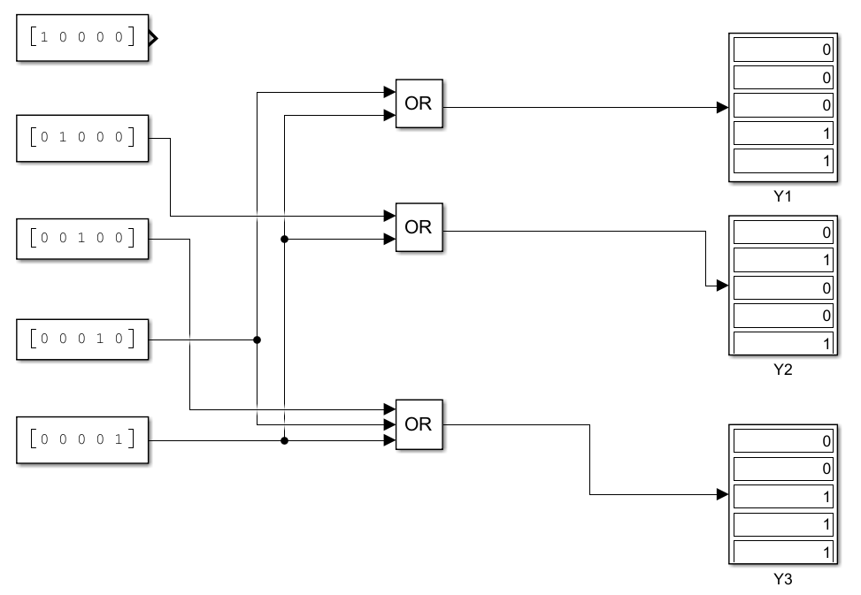

Задание 2
Функции |  |  | Аргументы (входы)
x₂ | x₁ | x₀ | y₇ | y₅ | y₂ | y₁ | y₀
(x₃) | (x₂) | (x₁) | (y₅) | (y₄) | (y₃) | (y₂) | (y₁)
0 | 0 | 1 | 1 | 1 | 1 | 1 | 0
0 | 1 | 0 | 1 | 1 | 1 | 0 | 1
1 | 0 | 0 | 1 | 1 | 0 | 1 | 1
1 | 0 | 1 | 1 | 0 | 1 | 1 | 1
1 | 1 | 1 | 0 | 1 | 1 | 1 | 1

y₁ = x₂ v x₁ v x₀
y₂ = x₂ v x₁ v x₀
y₃ = x₂ v x₁ v x₀
y₄ = x₂ v x₁ v x₀
y₅ = x₂ v x₁ v x₀

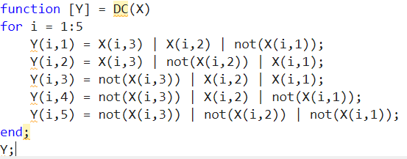

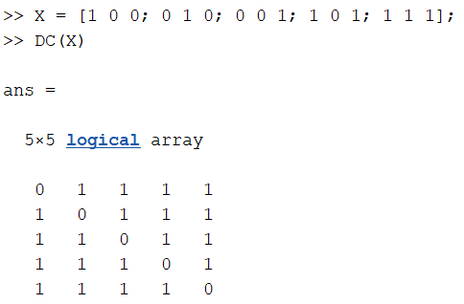
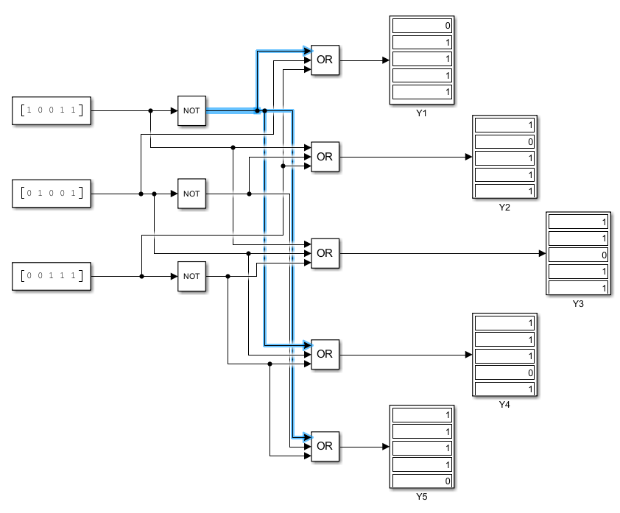

Задание 3
Z = (y1vD1) * (y2vD2) * (y3vD3) * (y4vD4) * (y5D5)
